*2019 Anomaly Detection using Convolutional Spatiotemporal Autoencoder*

**Abstract:**

The model consists of two significant aspects, one for representation of spatial features (convolutional layers) and one for temporal progression of spatial features (LSTM).

Methodology:

**Input Video:**

The proposed system uses input as video.

**Video to Image Frames:**

FFMPEG is an open source transcoding tool which can extract images from videos.

**Preprocessing:**

Frame is resized to 227 x 227.

All pixel values are scaled between 0 and 1.

**Normalization:**

Normalization is performed by subtracting every frame from global mean image.

$$Global Mean Image=\frac{X}{Y}$$

Where X is the sum of all pixel values of every frame in training dataset, Y is the total number of pixels.

Frames are converted into grey scale and have unit variance and zero mean.

**Feature Learning:**

Convolutional spatial and temporal autoencoder.

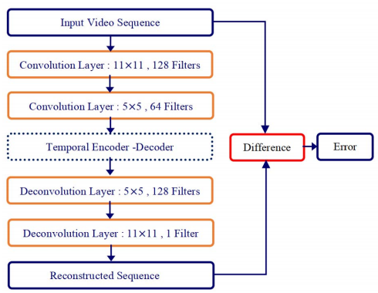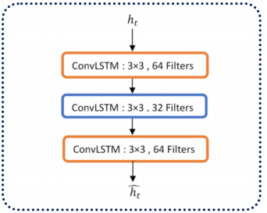

**Thresholding:**

Compare reconstruction error.